The Correlation Between High School Graduation Rates and Security Cameras

Noah Carey
University of Maryland College Park
URSP 688Y: Data Science & Smart Cities
Professor Harvey
May 5th, 2025

Introduction
The interaction between increased surveillance in schools and high school graduation rates is a well-documented phenomenon, but there has not been research conducted to see if the prevalence of surveillance in the general environment also has an effect. For this investigation, I chose Baltimore City, Baltimore County, and D.C. as my study areas. Baltimore city and county, due to their proximity, should provide an interesting contrast with each other. As well, Baltimore city and D.C. are both highly urbanized cities with the perception of high surveillance, so if the assumption that high surveillance leads to lower high school graduation rates is correct, they should have similar results. Regression analysis will be used with high school graduation rates and the number of security cameras per district. In addition, the proximity of security cameras to the location of high schools will be examined to see if there are any noticeable effects.
Methodology
The first step in my research was to find all the datasets that I would need for my analysis. The majority of my work was conducted in ArcGIS Pro and required the use of shapefiles. Shapefiles for the high school districts of Baltimore County and the attendance zones of D.C. were collected from the open data sites of each respective government. Baltimore city does not have high school districts, instead allowing for open enrollment in any high school in the city. In lieu of that, I used the elementary school zones for the city. This was not simply out of convenience; this dataset already had the high school graduation rates paired with each district. Continuing on with graduation rates, both had to be manually added to the districts for the other two study areas.
The next major dataset was the location of security cameras. Baltimore city was the easiest, as they already had a shapefile of every camera in the city available on their open data site. Baltimore county had their truck cameras available on their site, but I had to contact their GIS team in order to get their red light and speed cameras. For D.C., while they do have an interactive portal online, there was no way to download the data directly. Instead, I used another site, Surveillance Under Surveillance, a site that used the base of Open Street Maps to allow for open-source reports of cameras across the world. For better resolution, I had to download the cameras of D.C. as a .csv in three sections and merge them in ArcGIS, and then remove cameras that were outside of D.C.
The last section to find were the locations of the high schools for each study area. Baltimore county had their high schools listed as shapefile on their site, but for Baltimore city and D.C., I had to remove all elementary and middle schools from the dataset.
Analysis
With all datasets uploaded to ArcGIS and properly cleaned, I could then start my analysis. I started by doing an intersect of security cameras and school districts. This would serve as my metric to evaluate how much surveillance there is in each school district. This was done using ArcGIS’s intersect geoprocessing tool. This gave me three excel files when exported, which I combined into one for ease of use. I performed regression analysis on each one to find their $r^{2}$to serve as their correlation factor. The lowest correlation factor was for Baltimore County, at 1.37E-06, basically zero. The second highest was for Baltimore city, at .135. This implies very low correlation. The highest was in D.C., at .222. However, when the outliers of Eastern and Cardoza, with 389 and 174 cameras respectively, were removed, the correlation factor was even lower, at only .0011. While Baltimore city does have a negative trendline for the overall data, the very low $r^{2}$ value shows that the two variables are not correlated.

Figure 1: Linear Regression for Baltimore City

Figure 2: Linear Regression for Baltimore County

Figure 3: Linear Regression for D.C.

Figure 4: Linear Regression for D.C., Outliers Removed
The second portion of my analysis was to investigate if proximity had any affect on graduation rates. This was a bit more difficult to show mathematically. ArcGIS did not have a tool that allowed for cameras, even at a city level, to be grouped easily to a singular point for a cluster. Instead, the maps for each study area had to be investigated to gauge proximity. The data for Baltimore city is a bit confusing, due to the disconnect between the districts and school locations. An initial look may lead to the conclusion that camera density does have an effect on graduation rates, but some schools buck this trend, such as Digital Harbor High and Renaissance Academy, which are both schools surrounded by cameras but still have high graduation rates. Similarly, when looking at the districts directly, we see a mix of districts graduation rates even when they have high levels of security infrastructure.
Baltimore county shows even less of a trend. Ares with a high number of cameras, like Towson High and Loch Raven High have higher graduation rates than some areas with very few cameras, like Overlea High School or Parkville High School. As an even further countermeasure, the district with only one camera, Hereford High School, has a level of high school graduation, further reducing this correlation. Proximity is, again, a non-factor. Catonsville High School is surrounded by nearby cameras, but has a high graduation rate.
Lastly is D.C., which continues the rate of the other two study areas. Cardoza and Eastern are both outliers, having high numbers of security cameras in their district mainly due to having the Mall and other governmental sections of D.C. within their zones. But other zones are more on par with each other in terms of the number of cameras per district, but graduation rates still fluctuated between zones. Proximity was, again, a non-factor. The school with the highest density of nearby cameras, Dunbar High School, had a much higher graduation rate than schools with further away cameras, like Anacostia.
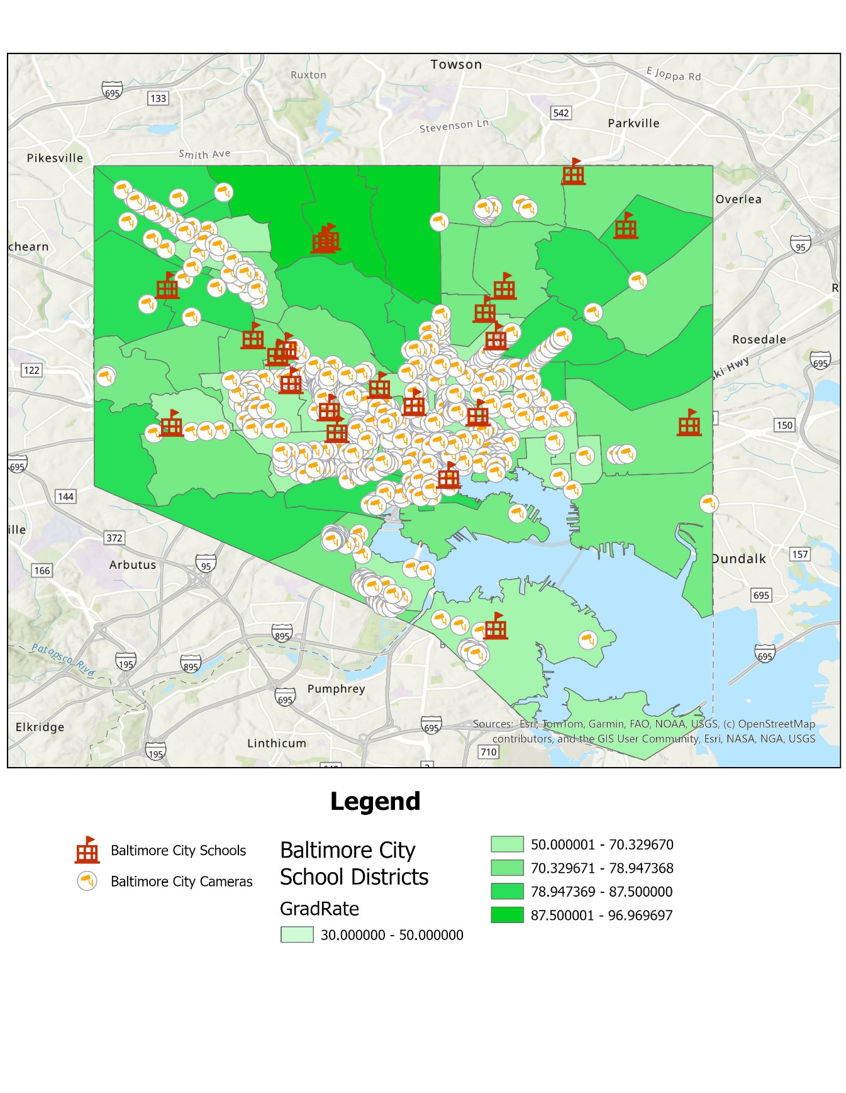
Figure 5: Cameras and School Locations; Baltimore City
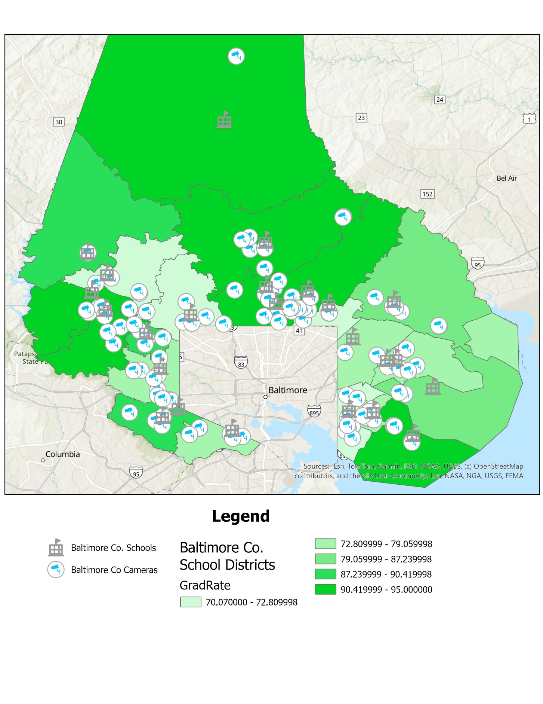
Figure 6: Cameras and School Locations; Baltimore County

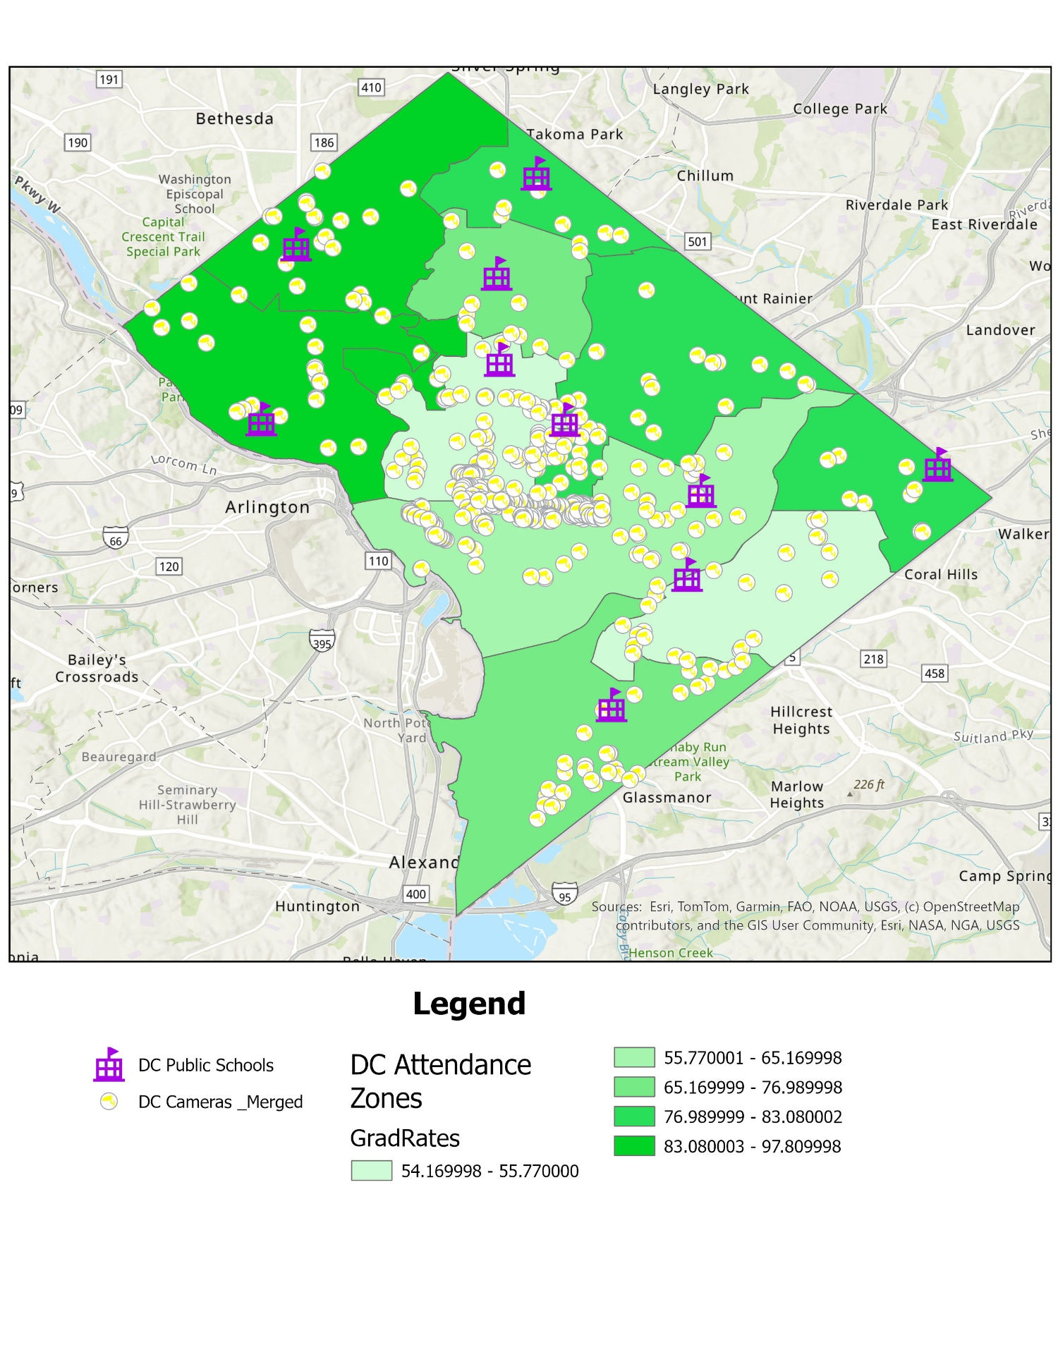
Figure 7: Cameras and School Locations; D.C.

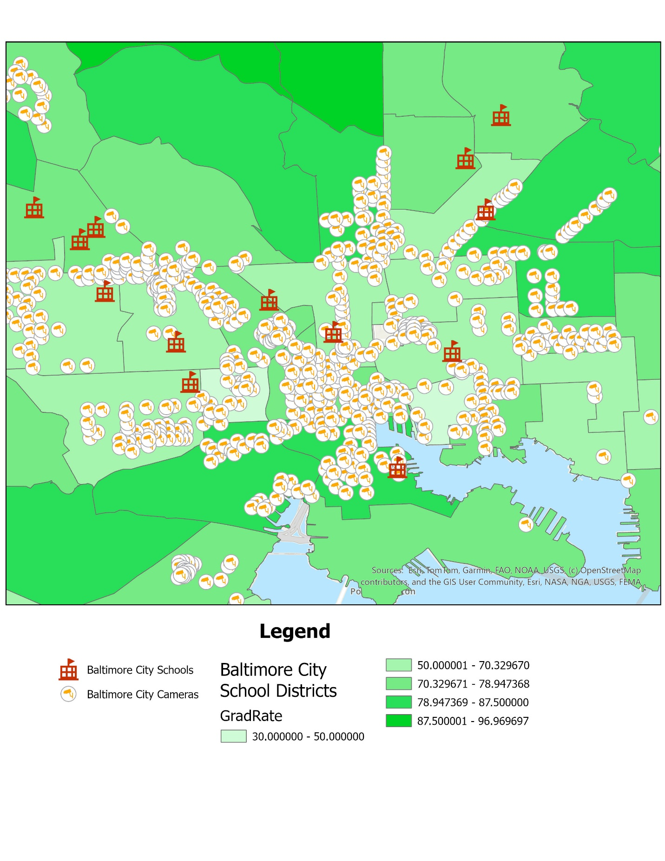

Figure 8: Cameras and School Locations; Baltimore City, Close-up

Limitations and Conclusion
This was a very exploratory study, and as such it could have been improved in many ways. I relied on online sources for security camera data, and this data did not include private security cameras, like Ring, and could not investigate if they also have an effect. Another limiting factor was sample size. Across all three study zones, only 51 schools were included in this study, which I would evaluate as a low sample size. In addition, a good third of the data did not line up cleanly with the rest, that being the Baltimore city data due to Baltimore not having tradition school districts. If I was to expand this study, I would want to find a greater sample size of schools and geographic areas, to also do a comparison between more urban and rural areas, which I attempted with the inclusion of the city and county of Baltimore.
Overall, this study found no correlation between the prevalence of security cameras and high school graduation rates. The low $r^{2}$ value indicated low to no correlation for all study areas, and at an even lesser extent when outliers were removed. In addition, proximity was not a factor in graduation rates, as high schools in closer proximity or no proximity to security cameras had varying levels of educational attainment. This was consistent across all study areas, both in denser urban areas like Baltimore city and D.C., and the more rural and suburban areas of Baltimore County.
While not included in my analysis, you could draw another conclusion from this study. The high school graduation rates could likely be correlated with several socio-economic or demographic features, such as poverty or minority status for each zone. This may have a greater correlation factor than security camera density and could also lead into a discussion on security camera placement in vulnerable areas.
These results lead me to two possible conclusions. The first is that there does not exist enough of a ‘surveillance culture’ outside of schools to affect high school graduation rates to a similar extent we see within schools. In other words, the environmental factor of security cameras is not as prevalent as they are in school. The second is that outside surveillance has no effect on graduation rates. Both of these conclusions would require further investigation, preferably in areas of even higher surveillance, to see which is correct or if it varies across regions.

References:
Baltimore City (2025) Baltimore City Schools https://data.baltimorecity.gov/datasets/baltimore::baltimore-city-schools/about
Baltimore City (2026) CitiWatch Camera Locations https://data.baltimorecity.gov/datasets/baltimore::citiwatch-camera-locations/about
Baltimore County Government (2025) High Schools https://opendata.baltimorecountymd.gov/datasets/BC-GIS::high-schools-1/about
Baltimore County Government (2025) High School Districts https://opendata.baltimorecountymd.gov/datasets/BC-GIS::high-school-districts/about
Baltimore County Government (2023) Truck Height Cameras https://opendata.baltimorecountymd.gov/datasets/BC-GIS::truck-height-cameras/about
Baltimore Neighborhood Indicators Alliance (2023) High School Completion Rate - Community Statistical Area https://data.baltimorecity.gov/datasets/bniajfi::high-school-completion-rate-1/about?layer=0
District of Columbia Public Schools (2023) DCPS 2023 Graduation Data Overall Subgroup https://dcps.dc.gov/publication/dcps-data-set-graduation-rates
Maryland State Department of Education (2023) Report Card https://reportcard.msde.maryland.gov/SchoolsList/Index?l=03
Open Data DC (2025) DC Public Schools https://opendata.dc.gov/datasets/DCGIS::dc-public-schools/about
Open Data DC (2023) School Attendance Zones (Senior High) https://opendata.dc.gov/datasets/DCGIS::school-attendance-zones-senior-high/about
Open Street Maps Surveillance Under Surveillance https://mapcomplete.org/surveillance.html

